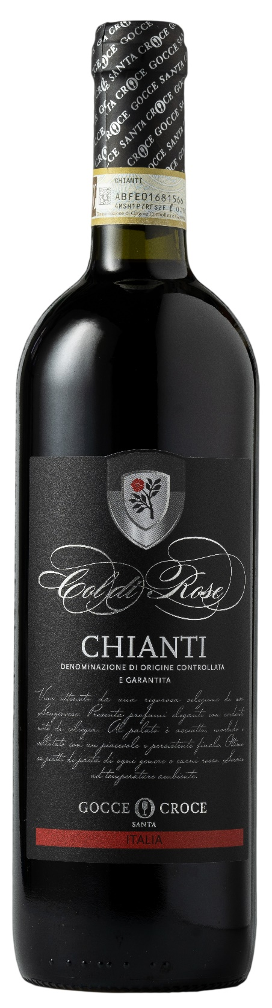
CHIANTI DOCG – COL DI ROSE

Grape: Sangiovese 100%
Alc. Vol.%: 12,5
Vintage: 2024
Residual sugar g/l: 4,0
Total acidity g/l: 5,2
Region: Tuscany
Production zone: Vineyards in northern Tuscany
Capacity: 750ml

CHARACTERISTICS

Vinification: Traditional peel maceration at a controlled temperature
Aging: At least 6 months in steel tanks
Yield per ha: 9000kg
Colour: Brilliant red with garnet reflections
Bouquet: Elegant, winy, with noble tannins
Flavour: Dry, smooth and pleasant with a long-lasting finish

SERVING SUGGESTIONS

Best enjoyed with pasta and red meat.
Serving temperature 18°C
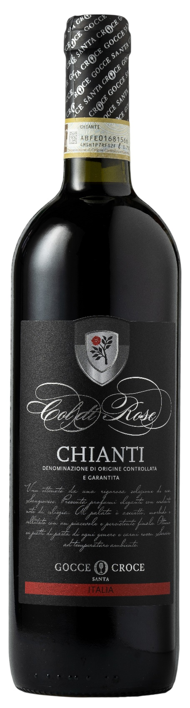
TECHNICAL INFORMATION / PALLETIZING

Size 750ml:
Article Nr. V08001A
GTIN-13 bottle 8017868000648
GTIN-13 carton 8017868002215
Closure Cork
Bottles / carton 6 bottles
Pallet size 80x120cm
Cartons/layer 25
Cartons/pallet 125
Kg/carton 7,3
Kg/pallet 895

Contains sulphites
GMO Free
Revisione 01. 14.05.2026

